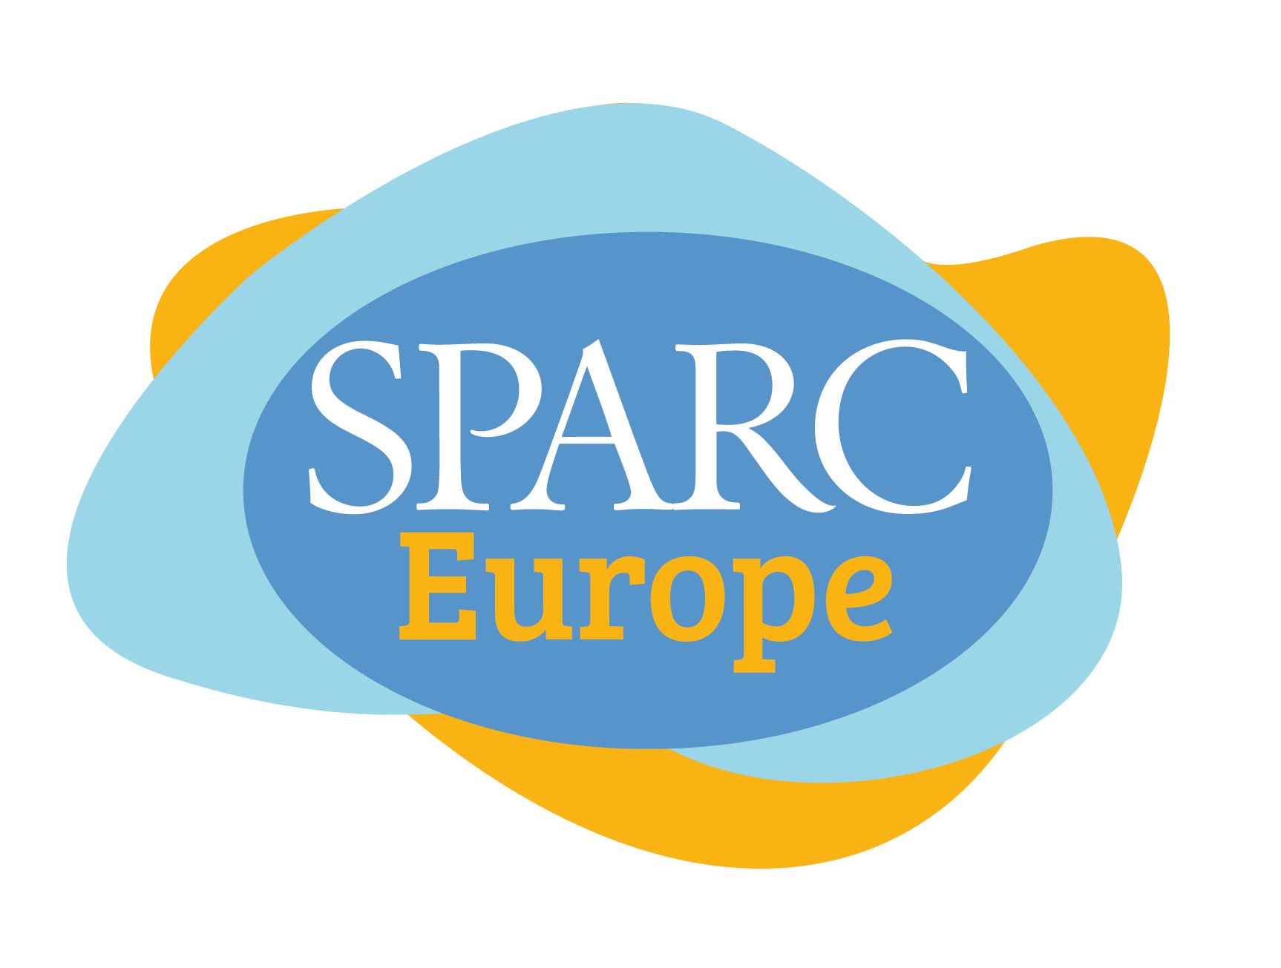
Making Open the Default
SPARC Europe Workshop
Satellite meeting to the LIBER Annual Conference 2016
Wed, 29 June 2016, 09.00 – 10.45
Viktor Julius von Wright room
Paasitorni Conference and Congress Centre
Paasivuorenkatu 5 A, 00530 Helsinki
PROGRAMME
09:00 – 09:15 Introduction, Lars Bjørnshauge
09:15 – 10.15 Reflections from the research community on what libraries and researchers can do to make Open the default
Current open research practice in Computational Biology. Dr Stephen Eglen, University of Cambridge, UK
(Not such) New challenges for Open Access. Ivana Hebrang Grgic, University of Zagreb, Croatia
Towards a global open access policy, Antonin Delpeuch, École Normale Supérieure, France
Norway’s national OA policy. Prof. Torkel Brekke, University of Oslo
10.15 – 10.30 The Metric Wave. Jan Erik Frantsvåg, UiT The Arctic University of Norway
10.30 – 10.45 Coffee

*
The SPARC Europe Annual Members Meeting follows on from this event.
Members – or those interested in joining SPARC Europe – are welcome to attend!

SPARC Europe Annual Members Meeting
Satellite meeting to the LIBER Annual Conference 2016

Wed, 29 June 2016, 10.45 – 12.00
Viktor Julius von Wright room
Paasitorni Conference and Congress Centre
Paasivuorenkatu 5 A, 00530 Helsinki

AGENDA

- Approval of the Agenda
- A new strategy for SPARC Europe
- SPARC Europe highlights
- Financial report 2015 and budget for 2016
- Revised statutes for SPARC Europe
- Supporting academic openness and funder compliance: a new institutional licence and model policy.
Chris Banks, Imperial College London
- SPARC Europe’s next steps
- AOB

Thank you very much for supporting us in making further change by
being a SPARC Europe member

